**Disclosure**

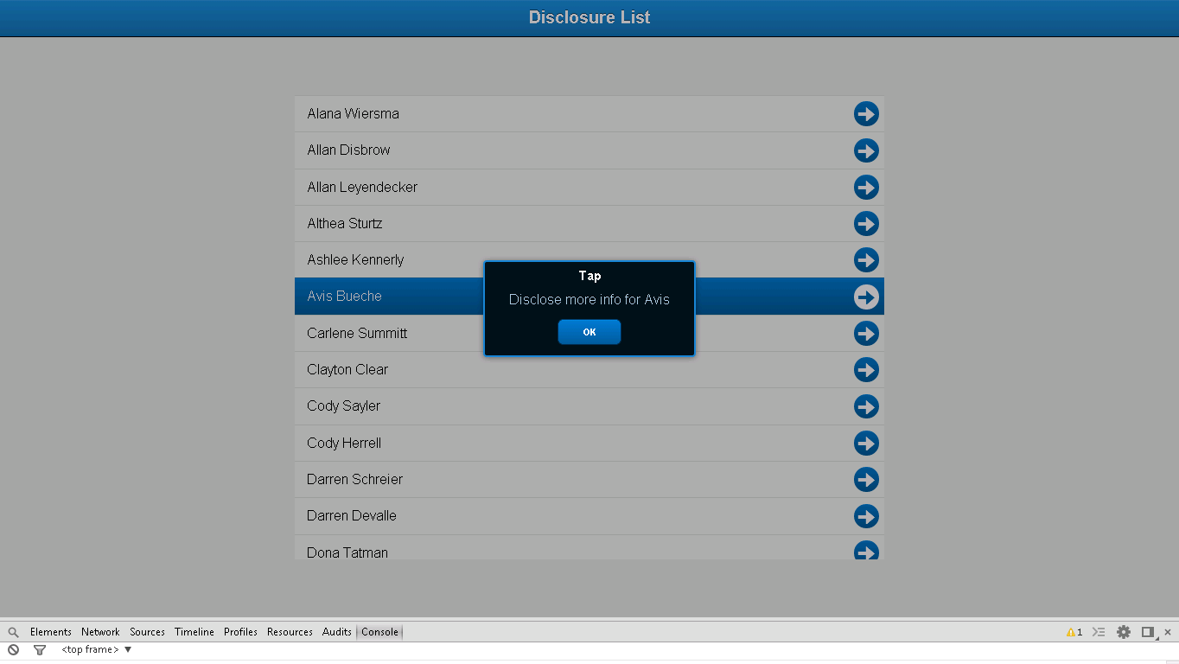

**Snapshot 1.1**

**Code**

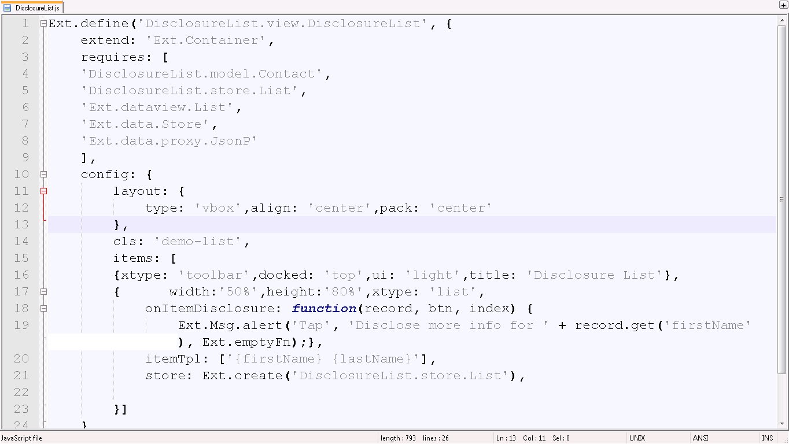

**Snapshot 1.2**

**Ext.define('DisclosureList.view.DisclosureList',** :->User defined class DisclosureList defined

**{**

**extend: 'Ext.Container',**  :-> Extends to Container (Super class to use in your application)

**requires: [**

**'DisclosureList.model.Contact',** :-> Contact model class is required here which is defined in model folder of DisclosureList application

**'DisclosureList.store.List',** :-> List store class is required here which is defined in store folder of DisclosureList application to add data in list

**'Ext.dataview.List',** :-> inbuilt List class is required to use list in your application

**'Ext.data.Store',** :-> inbuilt Store class is required to use store in your application

**'Ext.data.proxy.JsonP**:-> inbuilt JsonPclass is required to use proxy connection in your application

**],**

**config: {**

**layout: {**

**type: 'vbox',align: 'center',pack: 'center'**

**},**

**cls: 'demo-list',**

**items: [**

**{xtype: 'toolbar',docked: 'top',ui: 'light',title: 'Disclosure List'},**

**{ width:'50%',height:'80%',xtype: 'list',**

**onItemDisclosure: function(record, btn, index)** :-> Function is defined which will be called on click of each item of list.

**{**

**Ext.Msg.alert('Tap', 'Disclose more info for ' + record.get('firstName'), Ext.emptyFn);},**

**itemTpl: ['{firstName} {lastName}'],** :-> alert will be popped up with firstName and lastname on which you click

**store: Ext.create('DisclosureList.store.List'),** :-> store is defined to use in your application

**}]**

**}**

**});**

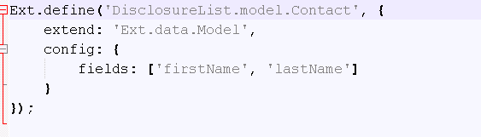

**Snapshot 1.2**

**Ext.define('DisclosureList.model.Contact', {**:-> User defined Contact model class is defined

**extend: 'Ext.data.Model',**  :-> Model super class is extended, which is required to define model

**config: {fields: ['firstName', 'lastName'}:**-> Field structure is defined

**});**

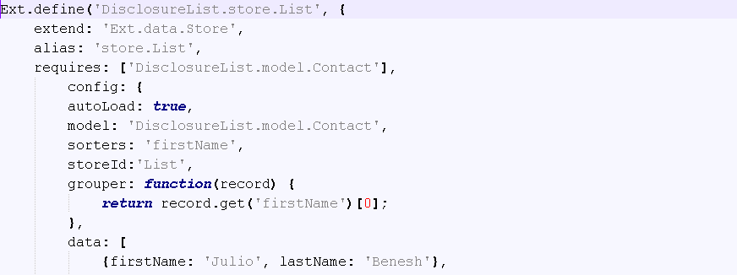

**Ext.define('DisclosureList.store.List',** :-> User defined store class is defined

**{**

**extend: 'Ext.data.Store', ,** :-> Super class store is extended which is required to use store

**alias: 'store.List',**

**requires: ['DisclosureList.model.Contact'],** :-> Store requires model class to use its field’s structure

**config: {**

**autoLoad: true,** To load list automatically

**model: 'DisclosureList.model.Contact',**

**sorters: 'firstName',**

**storeId:'List',** :-> store id is defined

**grouper: function(record) {**

**return record.get('firstName')[0];** :-> Function to return list according to firstName

**},**

**data: [**

**{firstName: 'Julio', lastName: 'Benesh'},**:-> Datalist to include in list

**FAQ**

1. What is **alias**?

Ans: It is used to give alternative name to class.

**Checkpoints**

1. Check carefully with your indentations as if you will miss any of the braces by mistake may reflect in compilation error.
2. See that your .js file starts with Ext.Define block and check that ends at the end of the program.
3. More than one items are separated by comma (,) separator and main program block of define is ended by semi colon (;)
4. Any value is assigned using colon (:) for example ui: 'confirm' and value is written inside single coats.
5. Items block starts with square brackets [] , which contains multiple members and also sub items.
6. Don’t forget to add entries of your files in app.js.

**Source Code**

